Extensive website relaunch:
Novus Dahle aiming to impress with new web presence
Five websites combined into one homepage

Lingen, 23 March 2023. Novus Dahle GmbH has totally revamped its internet presence. Instead of the five standalone sites used to date, all of the contents are now combined into one website on a clearly arranged homepage. Visitors to www.novus-dahle.com can find everything they need to know about products, companies and brands; the online magazine ‘WorkLife Experts’ is as entertaining as it is informative. Alongside the contents, the new website impresses with intuitive user guidance, smart consulting tools, responsive design and a clean, contemporary look.

The company itself Novus Dahle, as well as it four business divisions – Novus Office, Dahle Office, Novus More Space System and Novus Fastening Technology – each had their own website until now. The company site acted as a kind of central point of access for initial orientation and from here users could branch to the respective divisional sites. ‘But users found it confusing at times to navigate our five websites. On top of that, the two brands, Novus and Dahle, have grown together and forged closer links over time. That’s why the only logical choice was to present the contents in a common shop window, also bearing in mind the synergy effects that would emerge,’ explains Dominique Fanta, Brand Manager and Sales Director Global Accounts and Europe at Novus Dahle. ‘On www.novus-dahle.com we have now combined all our contents into a central website and arranged the information attractively in a contemporary design.’
All the necessary steps along the way, from concept to screen design, programming to maintenance of the new website, all took place in-house.

All products at a glance
Visitors can view all of Novus Dahle’s product categories by simply moving the cursor over the menu. And there are quite a few: the portfolio ranges from traditional items of office equipment, such as staplers and perforators, shredders, guillotines and presentation tools to well-designed products such as ergonomic workstation equipment – e.g. monitor support arms or office lights – to universally usable staple guns and rivet tools for building sites and workshops. Fanta: ‘Now users can immediately find the desired product group at a glance, but are also invited to browse and discover.’ If they want to find information about a specific product, they can use the filters in the respective category or the smart search function. The detailed pages offer numerous illustrations in addition to the product features, plus suitable accessories and bundling options with other products from Novus Dahle. ‘And in the “Industries” section, we present a variety of solutions for use of our products in the office and facility, at point of sale or in industry and trade,’ explains the brand manager.

Added value for users thanks to comprehensive consultation
Users can access product information in the service area, while brochures and catalogues are available centrally for download. In addition, visitors have the option of compiling and downloading individual PDF brochures. Various consulting tools – including the shredder advisor or the staple finder or rivet tools finder in the tools section – make it easier to select the required product and therefore create real added value for users. Just like the chat tool, which enables direct contact with the sales team in real time, thereby offering a personal online consulting experience: ‘The chat tool is currently available for monitor arms and office lights, in other words, generally for Novus More Space System products. Gradually, however, we expect it to be rolled out in all Novus Dahle areas,’ explains Fanta. The rich and varied online magazine ‘WorkLife Experts’ from Novus Dahle continues to impress with an exciting mix of creative craft ideas and DIY instructions as well as useful tips, for example, on ergonomics and health and safety in the workplace. Anyone who wants to learn more about the company and the individual brands can go to the ‘About us’ section for more details. This section contains information about upcoming trade fairs and other events, selected reference projects, press services and a careers area. And if visitors have any further questions, they can simply fill out the contact form.

International focus, technically up to date
‘An internationally active company like Novus Dahle must of course cater for its customers linguistically,’ emphasises Fanta. ‘For this reason, the website is available in seven languages: German, English, French, Spanish, Dutch, Czech and Polish.’ It goes without saying that the new website meets the highest technical standards. TLS encryption ensures safe and secure surfing; the responsive design gives tablet and smartphone users convenient access to the contents. ‘With our new cross-divisional website, we can present ourselves on the international stage and prepare ourselves for the future.’

782 words | 4,991 characters

Website link: www.novus-dahle.com

For more information, please contact Novus Dahle GmbH, Breslauer Straße 34–38, 49808 Lingen (Ems), Germany, phone: +49 (0) 591 91400, fax: +49 (0) 591 9140811, www.novus-dahle.com, info@novus-dahle.com.

About Novus Dahle

Novus Dahle GmbH supplies products and system solutions to help people work more comfortably and more efficiently. The specialist in innovative office technology is synonymous with high-tech devices and ‘German engineering’ and guarantees sophisticated, high-quality products. Novus Dahle is a subsidiary of the emco Group, based in Lingen, Germany. The international group has 1,200 employees worldwide and an annual turnover of EUR 150 million.
------------------------------------------------------------------------------------------

Contact us

Novus Dahle GmbH Phone: +49 (0) 591 9140243
Anne Heldermann Fax: +49 (0) 591 914094243
Breslauer Straße 34–38 Email: a.heldermann@novus-dahle.com
49808 Lingen (Ems) Website: www.novus-dahle.com

Images and captions

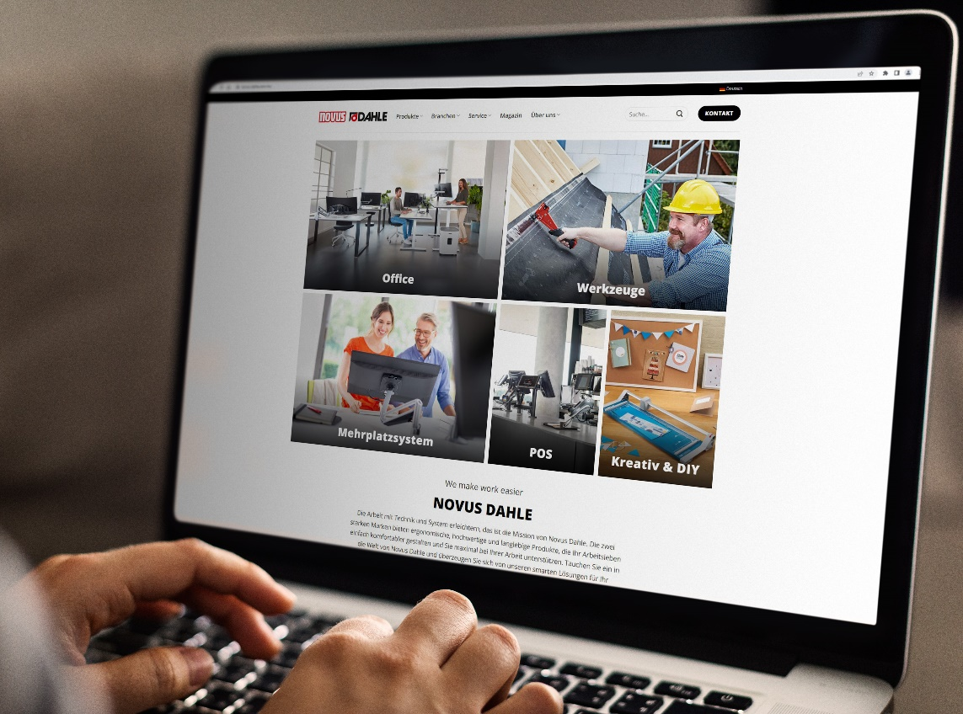
More service, more consultation: the new Novus Dahle website offers real added value for users. | © rawpixel.com on Freepik

