Ambiente and Creativeworld 2023:
Trade fair participation a roaring success
Lingen, 22 February 2023. Novus Dahle GmbH ends its appearance at this year’s Ambiente and Creativeworld consumer goods trade fairs in Frankfurt on a high. The new products and 2023 colour trends presented at Ambiente, plus Novus Dahle’s hands-on trade fair stand at Creativeworld went down a storm with the specialist audience. Novus Dahle expects to return in 2024.

In February, Novus Dahle took part in the Ambiente and Creativeworld trade fairs as an exhibitor. Ambiente was centred around the latest office trends and new products. At the stand in the Working Heroes area, the specialist audience got to see the latest trend colours of the Novus Color ID staplers and perforators, and test the sustainable re+new heavy-duty staplers. They also got to experience the brand-new Dahle Deskside document shredder plus the new ShredMATIC® model with P-5 security level.

Getting crafty
At Creativeworld, the company focussed on the use of Novus and Dahle premium products in creative projects. At our charming, homely stand, visitors got to cut, fold and staple to their heart’s content. In collaboration with Lisa Vogel from the Dekotopia blog, Dahle rotary trimmers and scissors were used to create colourful desk organisers from paper strips and decorative paper diamonds, which were then lent an atmospheric glow using fairy lights. Upcycling was also a core theme:
plain wooden stools were transformed into stylish, comfortable furniture with plush upholstery applied by hand using Novus tackers.

Creativeworld: a strong impression
‘Since this was our first time appearing as an exhibitor at Creativeworld, we had no idea beforehand whether we’d be able to access new target groups as we had planned, and we didn’t know how we’d go down with the visitors,’ reports Dominique Fanta, Sales Director Global Accounts & Europe and Brand Manager of Novus Dahle. ‘Our concerns faded away almost immediately. The huge influx of visitors, especially on the first two days of the fair, took us by surprise. Not just the quantity, but also the quality of the visitors impressed us: we got to speak to retailers and purchasers from Germany and abroad, as well as users, bloggers and other content creators. On top of that, our homely DIY concept was received well by the visitors. We captured their imagination by allowing them to see our products in action and test them for themselves. The feedback was really positive, as was the atmosphere.’

Positive feedback for Ambiente Working
Fanta is also happy with how Ambiente went. ‘The Novus Dahle stand in the Office Heroes area attracted a constant flow of visitors. Our key export partners from Europe and further afield were in attendance, alongside a few from Germany. As such, we were able to impress our partners and gain some exciting new contacts from across the board with our product innovations.’ However, the sales director points out that the selection of exhibitors in the Working area was quite small. Many of the exhibitors who had previously attended Paperworld were missing, claiming that the trade fair was hardly worth visiting for many of those interested. ‘When three quarters of the well-known stationery manufacturers aren’t appearing at Ambiente Working, this makes the fair much less appealing to the specialist audience, and therefore to our target groups.’

The two trade fairs in summary
‘Generally speaking, we’re very pleased with our participation in both trade fairs,’ Fanta summarised, adding: ‘We’ll definitely be back with a stand at next year’s Creativeworld, probably at Ambiente too if we fit in well with the other exhibitors.’

552 words | 4,045 characters

Website link: www.novus-dahle.com

For more information, please contact Novus Dahle GmbH, Breslauer Straße 34–38, 49808 Lingen (Ems), Germany, phone: +49 (0) 591 91400, fax: +49 (0) 591 9140811, www.novus-dahle.com, info@novus-dahle.com.

About Novus Dahle

Novus Dahle GmbH supplies products and system solutions to help people work more comfortably and more efficiently. The specialist in innovative office technology is synonymous with high-tech devices and ‘German engineering’ and guarantees sophisticated, high-quality products. Novus Dahle is a subsidiary of the emco Group, based in Lingen, Germany. The international group has 1,200 employees worldwide and an annual turnover of EUR 150 million.
------------------------------------------------------------------------------------------
Contact us

Novus Dahle GmbH Phone: +49 (0) 591 91 40 243
Anne Heldermann Fax: +49 (0) 591 91 40 94 243
Breslauer Straße 34–38 Email: a.heldermann@novus-dahle.com
49808 Lingen (Ems) Internet: www.novus-dahle.com

Images and captions

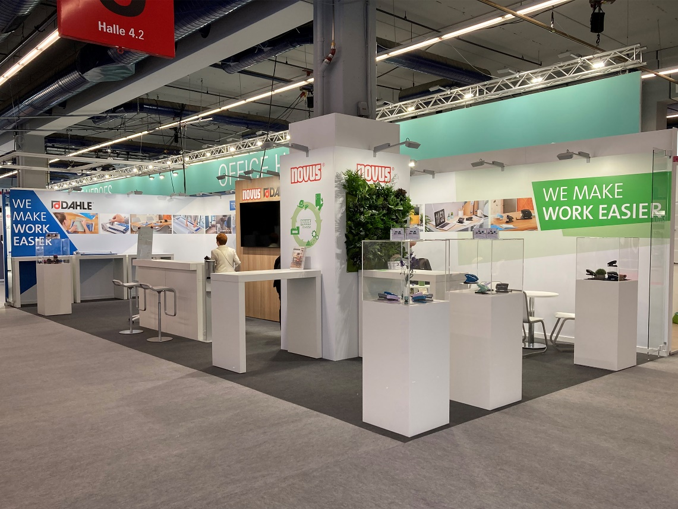
The Novus Dahle trade fair stand in the Office Heroes area at Ambiente.

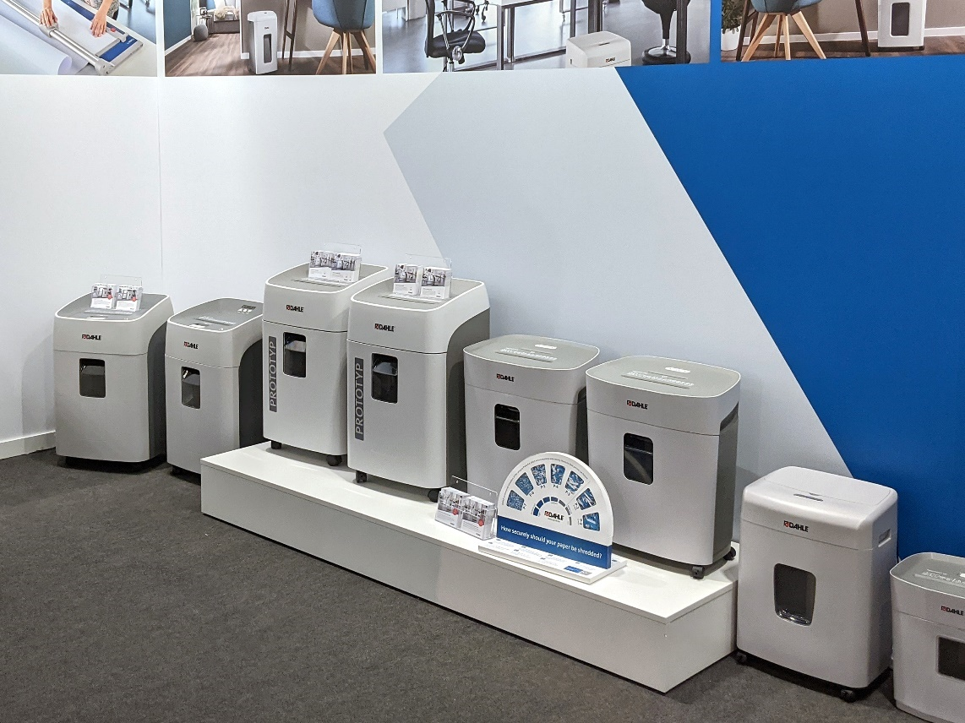
A selection of items from the Dahle document shredder range.
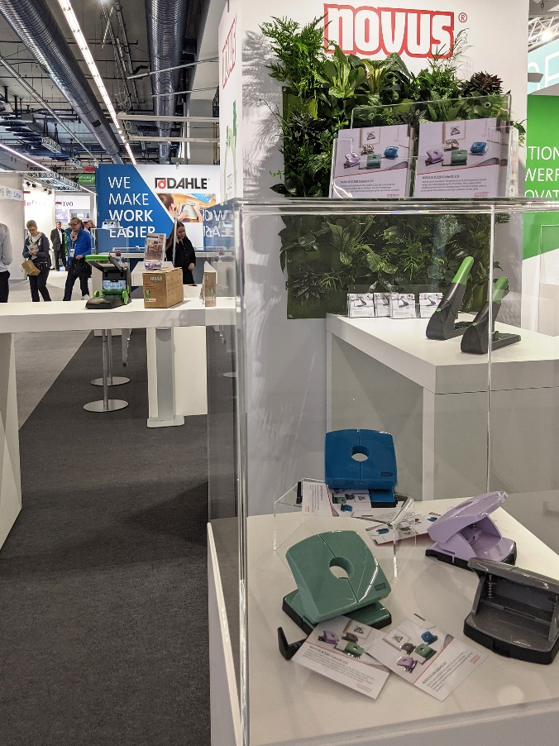
Centre stage: the much-talked-about Color ID 2023 trend colours and the re+new heavy-duty staplers by Novus.

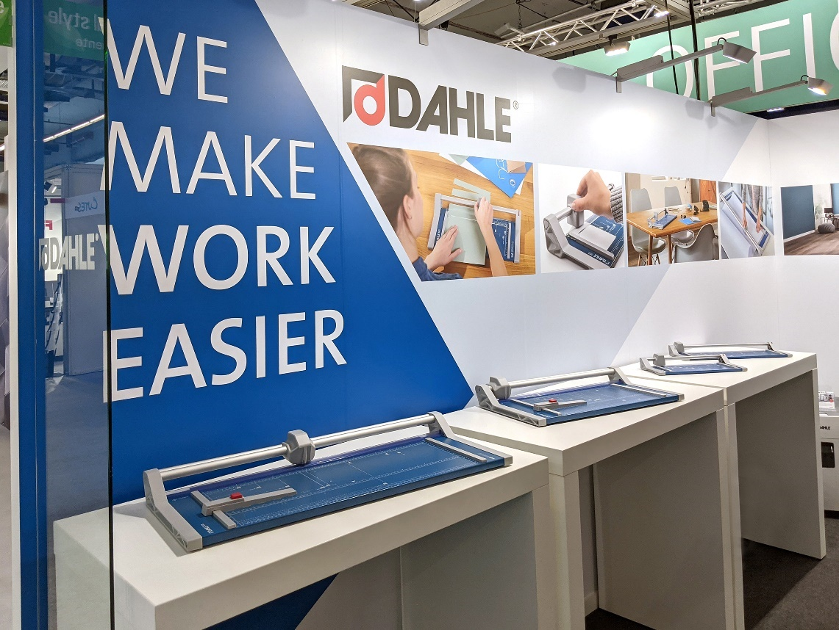
The exhibition wouldn’t have been complete without the Dahle rotary trimmers.

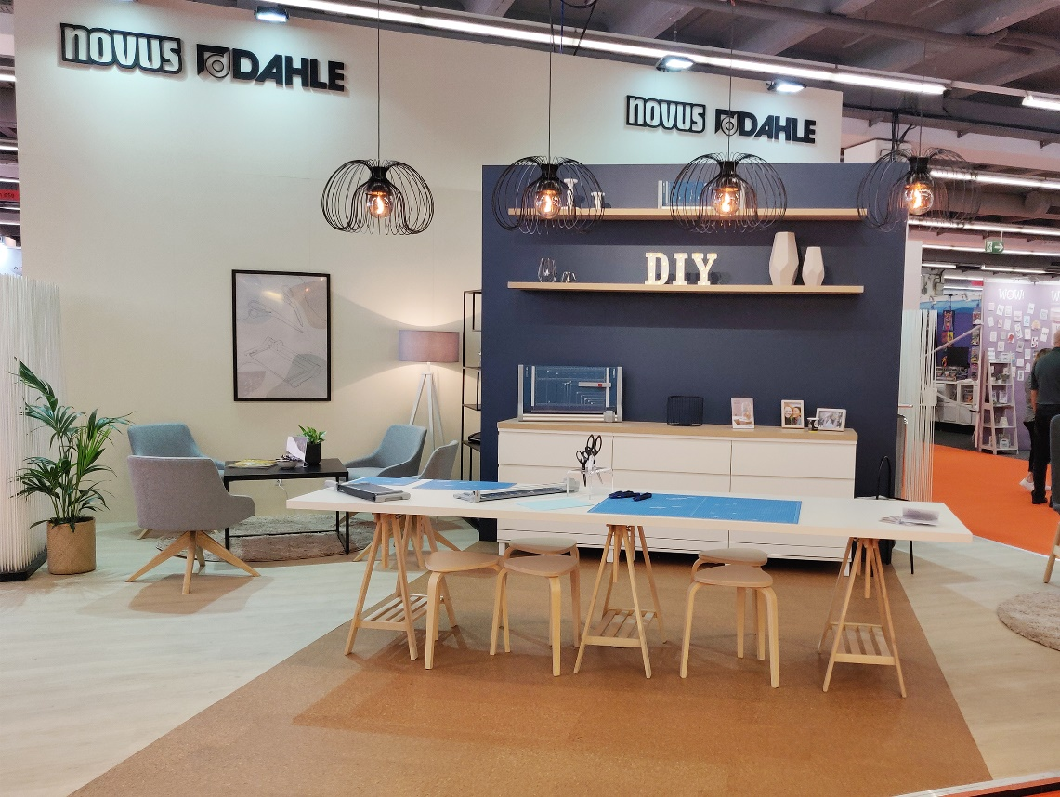
Novus Dahle presented a homely, hands-on exhibit at Creativeworld.

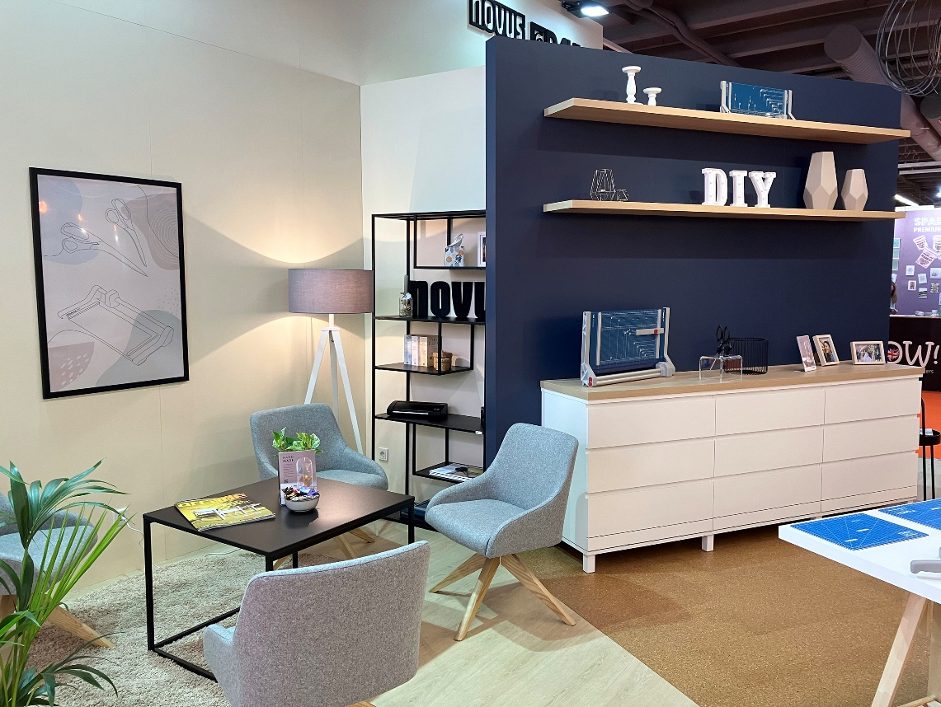
The cosy living room atmosphere attracted visitors to stop by for some crafts and conversation.

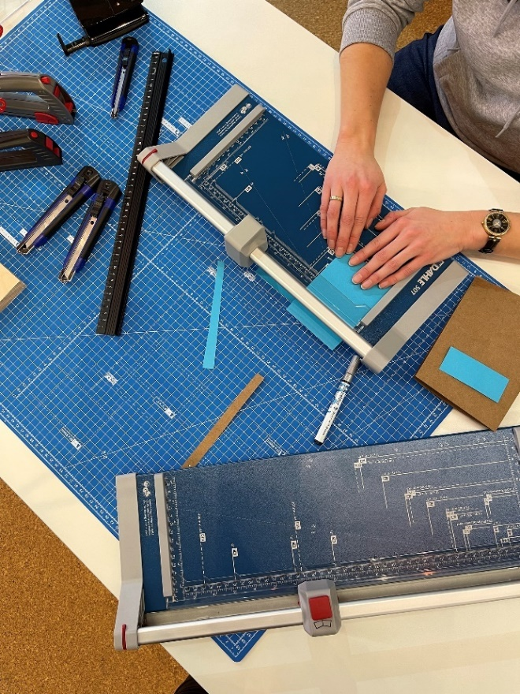
Visitors got to test the Dahle rotary trimmer for themselves and craft some decorations from paper.

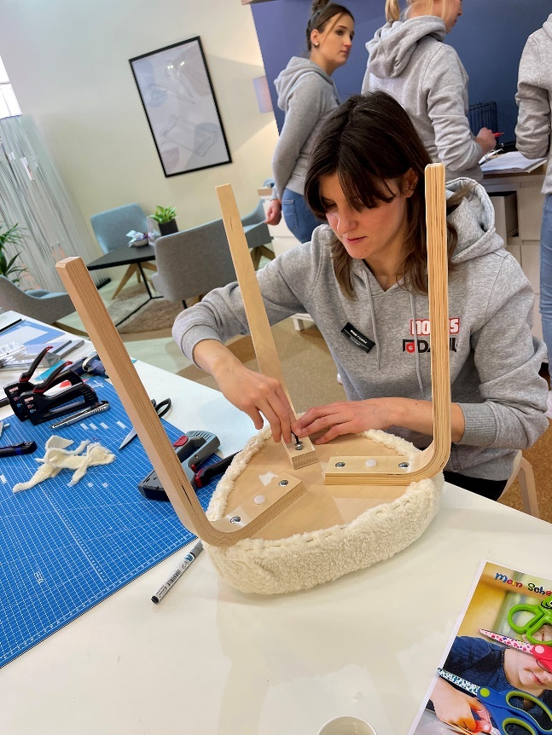
Lisa Vogel from the Dekotopia blog worked on exciting DIY projects such as custom upcycling of furniture.
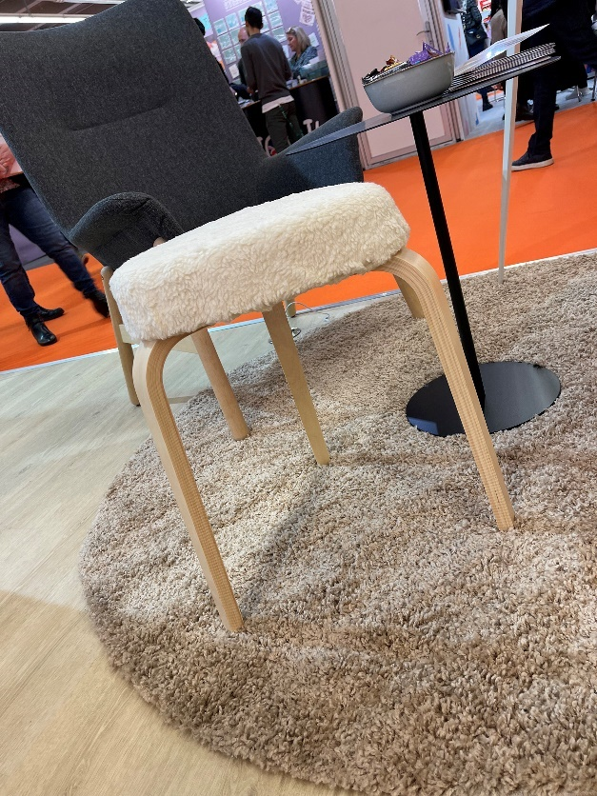
From series products to individual pieces: live upcycling with Novus hand tackers.

