The new ShredMATIC® shredder with P-5 security level:
Put your mind at further ease with data protection-compliant document shredding
It’s a well-known fact that the autofeed shredder from Dahle’s ShredMATIC® series is capable of shredding large quantities of paper in no time. Dahle is now adding the ShredMATIC® 300 P-5 shredder to its bestseller series. The new device features security level P-5 and can shred stacks of up to 300 sheets of paper containing confidential data – data protection-compliant, quick and convenient. All of which once again confirms Dahle’s status as a proven expert in secure data destruction.

In areas such as medicine, industry and research, large volumes of paper containing sensitive personal or confidential data must be regularly destroyed in a manner which is both reliable and in compliance with data protection legislation. Companies need a device they can trust to perform such tasks. And that’s what you get with the new ShredMATIC® autofeed shredder from Dahle: featuring security level P-5, it can shred documents that are subject to confidentiality and require protection, such as medical reports, construction plans and strategy papers, in a secure and efficient manner.

Three becomes four
The Dahle ShredMATIC® series previously comprised three autofeed devices with security level P-4 that could shred up to 90, 150 or 300 sheets in a single load, depending on the model.
Since their launch, these Dahle shredders have become real bestsellers thanks to their multitude of functions, user-friendliness and – last but not least – unbeatable speed. The predecessor model, the ShredMATIC® 300, can shred 300 sheets of standard paper in less than nine minutes, making it one of the fastest shredders on the market. The new model, the ShredMATIC® 300 P-5, is just as quick and efficient, and thanks to its high security level, is ideal for use e.g. in law firms, tax offices, labs or medical practices – or indeed anywhere where highly sensitive data is regularly disclosed. At 2 x 15 mm, the particles generated during the shredding process are so small that reproducing the destroyed data is virtually impossible and therefore highly unlikely. These devices therefore meet stringent data protection requirements and help further alleviate the stress of shredding highly sensitive data.

User-friendly and powerful
Like the other devices from the series, the ShredMATIC® 300 P-5 from Dahle is both durable and efficient, yet at the same time quiet and energy-saving when put into operation, despite its powerful motor. In addition, Dahle offers a 35-year guarantee on their high-quality MHP cutting rollers, so you’ll feel more relaxed from the moment you buy. Whether intended for use by one or more users, at a single workstation or centrally in an open-plan office: the device can be used at various locations, while castors also enable spatial flexibility. And the generous 40-litre waste container, which can hold up to 600 sheets, offers further convenience by eliminating the need for frequent emptying.

Extended guarantee
The extended guarantee provided by Dahle for products from the ShredMATIC® series gives you more security and peace of mind in your purchase. That’s because when customers buy a new ShredMATIC® shredder, they get a further one-year guarantee after registering the device. This means a three-year guarantee instead of the usual two years.
This promotion, which runs until 31 December 2023, is also valid for Dahle’s PaperSAFE® shredders.

550 words | 3,500 characters

Website link: www.novus-dahle.com

For more information, please contact Novus Dahle GmbH, Breslauer Straße 34–38, 49808 Lingen (Ems), Germany, phone: +49 (0) 591 91400, fax: +49 (0) 591 9140811, www.novus-dahle.com, info@novus-dahle.com.

Paper documents that must be treated confidentially are regularly found in particular in companies in the areas of industry, medicine and research. Accordingly, these must be destroyed in a secure and data-protection compliant manner.

About Novus Dahle

Novus Dahle GmbH supplies products and system solutions to help people work more comfortably and more efficiently. The specialist in innovative office technology is synonymous with high-tech devices and ‘German engineering’ and guarantees sophisticated, high-quality products. Novus Dahle is a subsidiary of the emco Group, based in Lingen, Germany. The international group has 1,200 employees worldwide and an annual turnover of EUR 150 million.
------------------------------------------------------------------------------------------
Contact us

Novus Dahle GmbH Phone: +49 (0) 591 91 40 243
Anne Heldermann Fax: +49 (0) 591 91 40 94 243
Breslauer Straße 34–38 Email: a.heldermann@novus-dahle.com
49808 Lingen (Ems) Website: www.novus-dahle.com

Images and captions

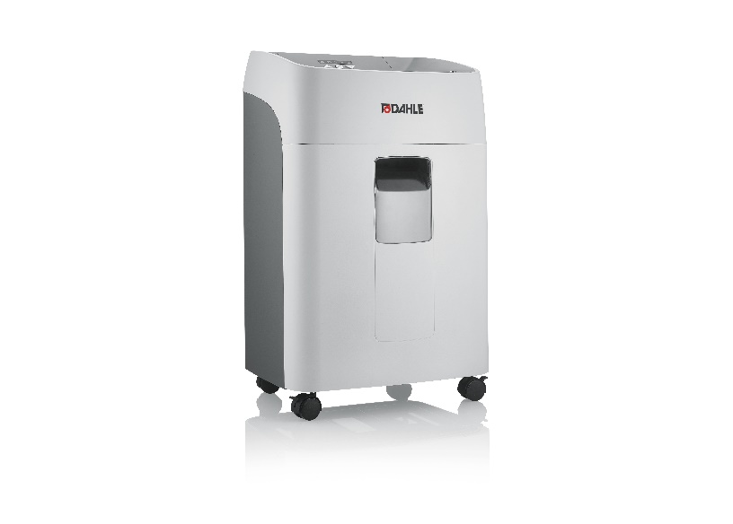
New addition to the ShredMATIC® family: the new ShredMATIC® 300 shredder with security level P-5.

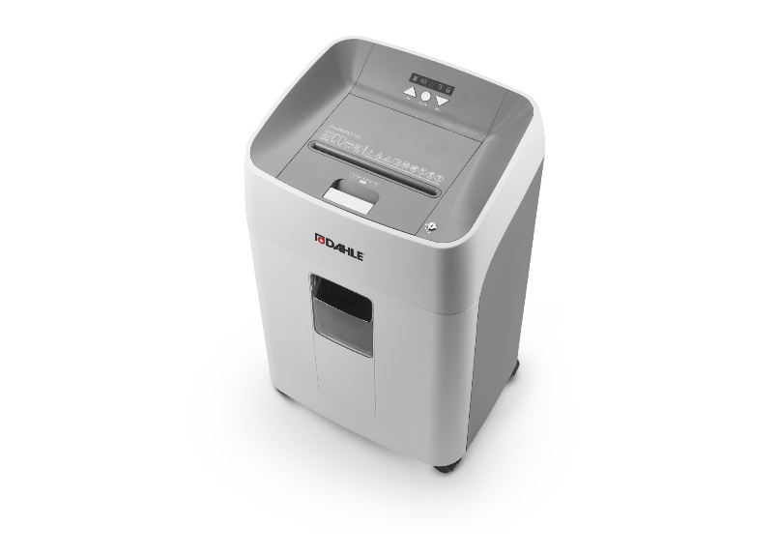
The well-presented control panel ensures user-friendliness, while castors enable flexible usage.

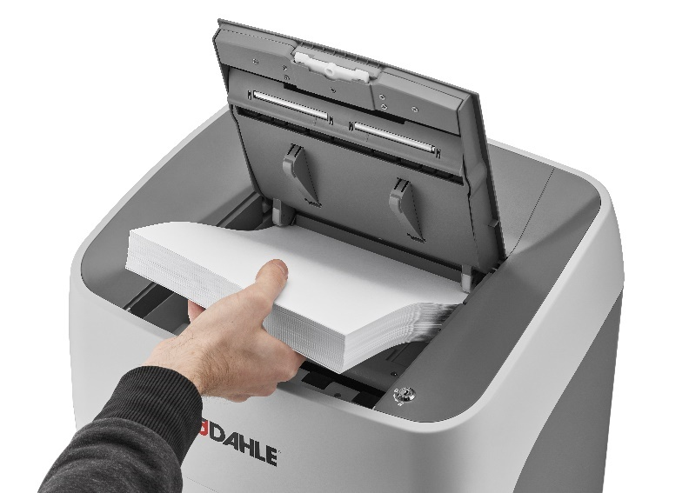
Simply insert your stack of paper and the ShredMATIC® 300 P-5 with its autofeed function will do the rest – secure, quick and data-protection compliant.

